Write a C program to implement the back end of the compiler.
Program:
#include<stdio.h>
#include<conio.h>
#include<string.h>
int main()
{
int n,i,j;
char a[50][50];
printf("enter the no: intermediate code:");
scanf("%d",&n);
for(i=0;i<n;i++)
{
printf("enter the 3 address code:%d:",i+1);
for(j=0;j<6;j++)
{
scanf("%c",&a[i][j]);
}
}
printf("the generated code is:");
for(i=0;i<n;i++)
{
printf("\n mov %c,R%d",a[i][3],i);
if(a[i][4]=='-')
{
printf("\n sub %c,R%d",a[i][5],i);
}
if(a[i][4]=='+')
{
printf("\n add %c,R%d",a[i][5],i);
}
if(a[i][4]=='*')
{
printf("\n mul %c,R%d",a[i][5],i);
}
if(a[i][4]=='/')
{
printf("\n div %c,R%d",a[i][5],i);
}
printf("\n mov R%d,%c",i,a[i][1]);
printf("\n");
}
return 0;
}
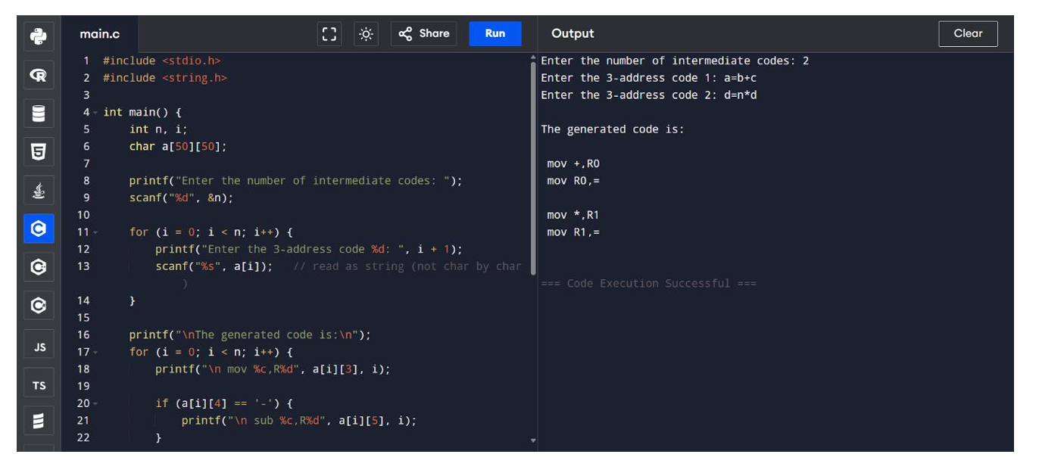
Exp. No. 19
Write a C program to compute LEADING( ) – operator precedence parser for the given grammar
E → E + T | T
T → T * F | F
F → ( E ) | id
Program:
#include<conio.h>
#include<stdio.h>

char arr[18][3] ={{'E', '+', 'F'},{'E', '*', 'F'},{'E', '(', 'F'}, {'E', ')', 'F'},{'E', 'i', 'F'},{'E', '$', 'F'},
{'F', '+', 'F'},{'F', '*', 'F'},{'F', '(', 'F'},{'F', ')', 'F'},{'F', 'i', 'F'},{'F', '$', 'F'}, {'T', '+', 'F'},
{'T', '*', 'F'}, {'T', '(', 'F'},{'T', ')', 'F'},{'T', 'i', 'F'},{'T', '$', 'F'}};

char prod[] = "EETTFF";
char res[6][3] ={ {'E', '+', 'T'}, {'T', '\0'}, {'T', '*', 'F'}, {'F', '\0'}, {'(', 'E', ')'}, {'i', '\0'}};
char stack [5][2];
int top = -1;

void install(char pro, char re) {
int i;
for (i = 0; i < 18; ++i) {
if (arr[i][0] == pro && arr[i][1] == re) {

arr[i][2] = 'T';
break;
}
}
++top;
stack[top][0] = pro;
stack[top][1] = re;
}

int main() {
int i = 0, j;
char pro, re, pri = ' ';

for (i = 0; i < 6; ++i) {
for (j = 0; j < 3 && res[i][j] != '\0'; ++j) {
if (res[i][j] == '+' || res[i][j] == '*' || res[i][j] == '(' || res[i][j] == ')' || res[i][j] == 'i' || res[i][j] == '$') {
install(prod[i], res[i][j]);
break;
}
}
}
while (top >= 0) {
pro = stack[top][0];
re = stack[top][1];
--top;
for (i = 0; i < 6; ++i) {
if (res[i][0] == pro && res[i][0] != prod[i]) {
install(prod[i], re);
}
}
}
for (i = 0; i < 18; ++i) {
printf("\n\t");
for (j = 0; j < 3; ++j)
printf("%c\t", arr[i][j]);
}
getch();
printf("\n\n");
for (i = 0; i < 18; ++i) {
if (pri != arr[i][0]) {
pri = arr[i][0];
printf("\n\t%c -> ", pri);
}
if (arr[i][2] == 'T')
printf("%c ", arr[i][1]);
}
getch();
}

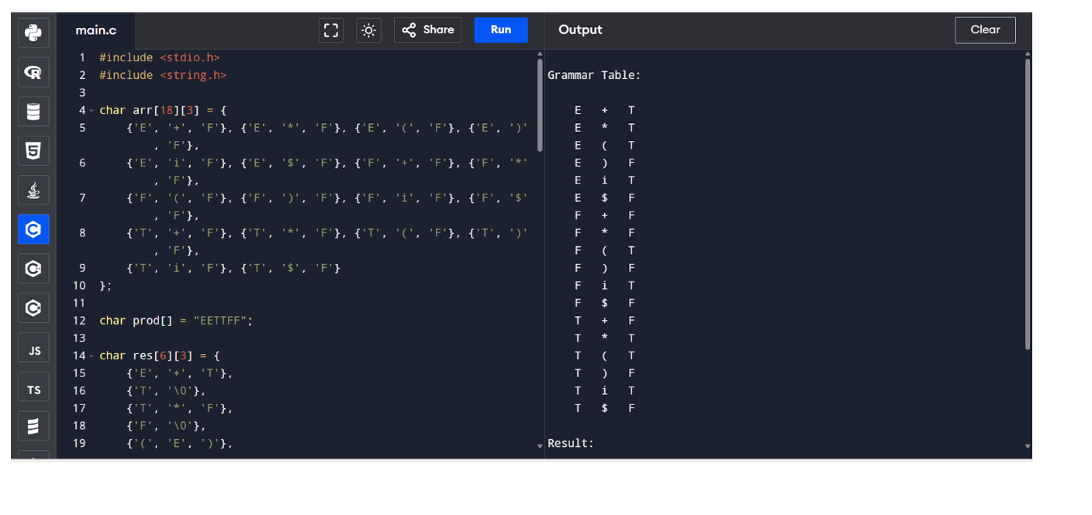

Exp. No. 20
Write a C program to compute TRAILING( ) – operator precedence parser for the given grammar
E → E + T | T
T → T * F | F
F → ( E ) | id
Program:
#include<conio.h>
#include<stdio.h>
char arr[18][3] ={{'E', '+', 'F'}, {'E', '*', 'F'}, {'E', '(', 'F'}, {'E', ')', 'F'}, {'E', 'i', 'F'},
{'E', '$', 'F'}, {'F', '+', 'F'}, {'F', '*', 'F'}, {'F', '(', 'F'}, {'F', ')', 'F'}, {'F', 'i', 'F'},
{'F', '$', 'F'}, {'T', '+', 'F'}, {'T', '*', 'F'}, {'T', '(', 'F'}, {'T', ')', 'F'}, {'T', 'i', 'F'},
{'T', '$', 'F'},
};
char prod[6] = "EETTFF";
char res[6][3] ={ {'E', '+', 'T'}, {'T', '\0', '\0'}, {'T', '*', 'F'}, {'F', '\0', '\0'}, {'(', 'E', ')'}, {'i', '\0', '\0'},};
char stack [5][2];
int top = -1;

void install(char pro, char re) {
int i;
for (i = 0; i < 18; ++i) {
if (arr[i][0] == pro && arr[i][1] == re) {
}
}
++top;
arr[i][2] = 'T';

stack[top][0] = pro;
stack[top][1] = re;
}

int main() {
int i = 0, j;
char pro, re, pri = ' ';

for (i = 0; i < 6; ++i) {
for (j = 2; j >= 0; --j) {

if (res[i][j] == '+' || res[i][j] == '*' || res[i][j] == '(' || res[i][j] == ')' || res[i][j] == 'i' || res[i][j] == '$') {
install(prod[i], res[i][j]);
break;
} else if (res[i][j] == 'E' || res[i][j] == 'F' || res[i][j] == 'T') {
if (res[i][j - 1] == '+' || res[i][j - 1] == '*' || res[i][j - 1] == '(' || res[i][j -
1] == ')' || res[i][j - 1] == 'i' || res[i][j - 1] == '$') {
install(prod[i], res[i][j - 1]);
break;
}
}
}
}

while (top >= 0) {
pro = stack[top][0];
re = stack[top][1];
--top;
for (i = 0; i < 6; ++i) {
for (j = 2; j >= 0; --j) {
if (res[i][0] == pro && res[i][0] != prod[i]) {
install(prod[i], re);
break;
} else if (res[i][0] != '\0') break;
}
}
}
for (i = 0; i < 18; ++i) {
printf("\n\t");
for (j = 0; j < 3; ++j)
printf("%c\t", arr[i][j]);
}
printf("\n\n");
for (i = 0; i < 18; ++i) {
if (pri != arr[i][0]) {
pri = arr[i][0];
printf("\n\t%c -> ", pri);
}
if (arr[i][2] == 'T')
printf("%c ", arr[i][1]);}
}
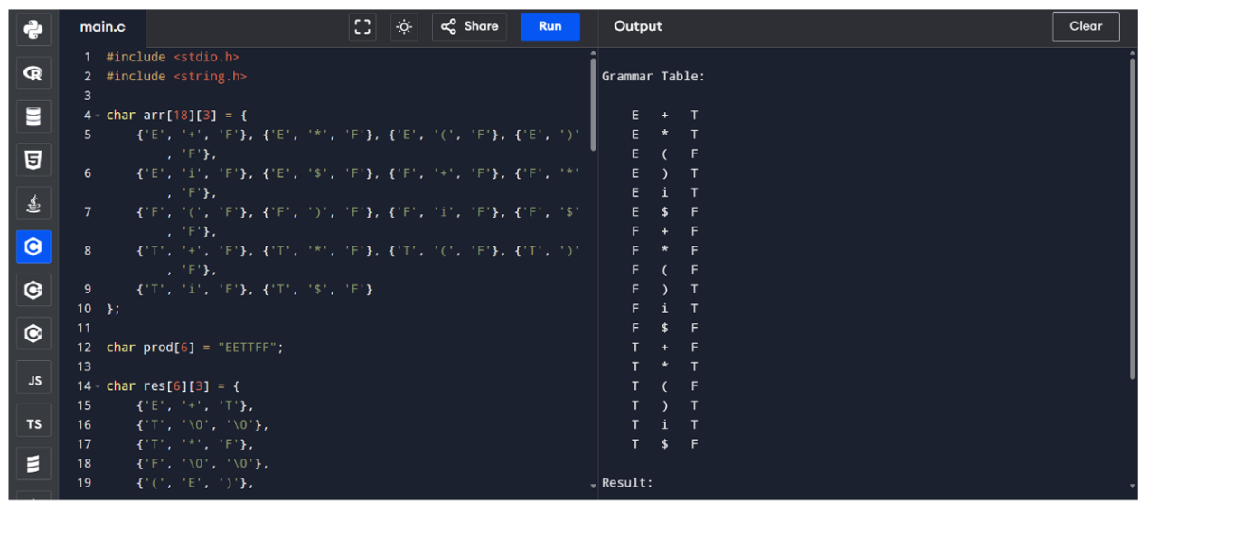
Exp. No. 21
Write a LEX specification file to take input C program from a .c file and count tthe number of characters, number of lines & number of words.
Input Source Program: (sample.c)
#include <stdio.h>
int main()
{
int number1, number2, sum;
printf("Enter two integers: ");
scanf("%d %d", &number1, &number2);
sum = number1 + number2;
printf("%d + %d = %d", number1, number2, sum);
return 0;
}

Program: (count_lines.l)
%{
int nchar, nword, nline;
%}
%%
\n { nline++; nchar++; }
[^ \t\n]+ { nword++, nchar += yyleng; }
. { nchar++; }
%%
int yywrap(void) {
return 1;
}
int main(int argc, char *argv[]) {
yyin = fopen(argv[1], "r");
yylex();
printf("Number of characters = %d\n", nchar);
printf("Number of words = %d\n", nword);
printf("Number of lines = %d\n", nline);
fclose(yyin);
}

Output:
G:\lex>flex count_line.l

G:\lex>gcc lex.yy.c

G:\lex>a.exe sample.c
Number of characters = 233
Number of words = 33
Number of lines = 10

G:\lex>

Exp. No. 22
Write a LEX program to print all the constants in the given C source program file.

Input Source Program: (sample.c)
#define P 314
#include<stdio.h> #include<conio.h>
void main()
{
int a,b,c = 30;
printf("hello");
}
Program: (countconstants.l)
digit [0-9]
%{
int cons=0;
%}
%%
{digit}+ { cons++; printf("%s is a constant\n", yytext); }
.|\n { }
%%
int yywrap(void) {
return 1; }
int main(void)
{
FILE *f;
char file[10];
printf("Enter File Name : ");
scanf("%s",file);
f = fopen(file,"r");
yyin = f;
yylex();
printf("Number of Constants : %d\n", cons);
fclose(yyin);
}

Output:

G:\lex>flex countconstants.l

G:\lex>gcc lex.yy.c

G:\lex>a.exe
Enter File Name : sample.c
314 is a constant
30 is a constant
Number of Constants : 2

G:\lex>

